ASSIGNMENT 3

1.module desi(

input[4:0] a,

input[4:0] b,

output[4:0] out

);

assign a=5;

assign b=5;

assign out=a&b;

initial begin

$display(" a=%b b=%b out=%b",$realtime,a,b,out);

end

endmodule

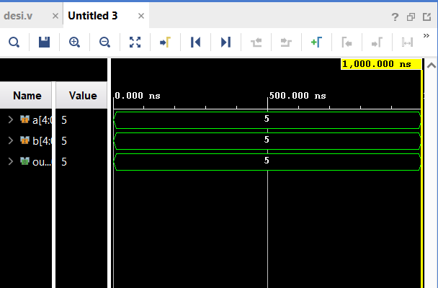

2. module desi(

);

wire[4:0] a,b;

assign a=5;

assign b=5;

wire[4:0] out=a|b;

initial begin

$display(" a=%b b=%b out=%b",$realtime,a,b,out);

end

endmodule

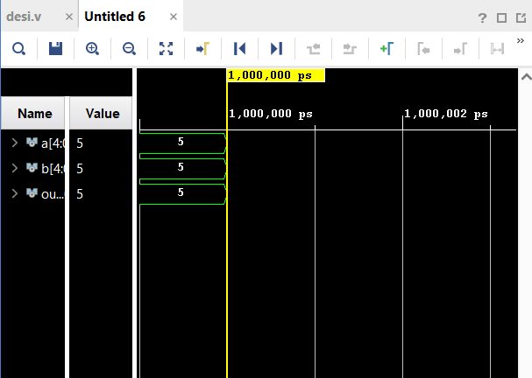

3.

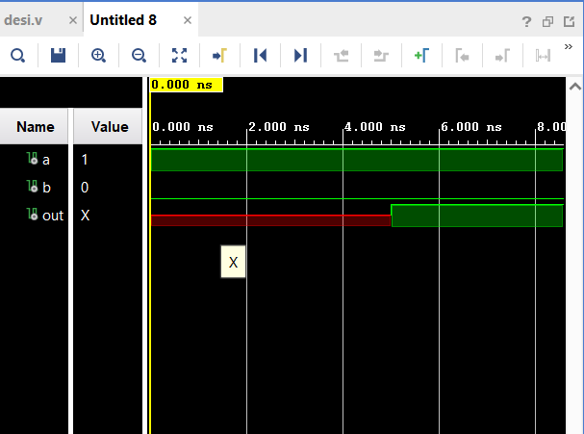

module desi(

);

wire a,b;

assign a=1;

assign b=0;

assign #5 out=a+b;

initial begin

$monitor(" a=%b b=%b out=%b",$realtime,a,b,out);

end

endmodule

4.

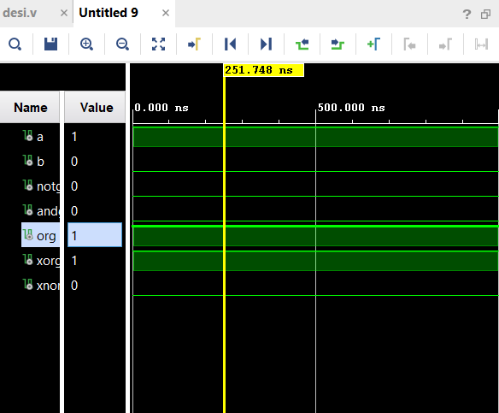

module desi(

);

wire a,b,notg,andg,org,xorg,xnorg;

assign a=1;

assign b=0;

assign notg=~a;

assign andg=a&b;

assign org=a|b;

assign xorg=a^b;

assign xnorg=a~^b;

initial begin

$monitor(" a=%b b=%b %b %b %b %b %b ",$realtime,a,b,notg,andg,org,xorg,xnorg);

end

endmodule

5.

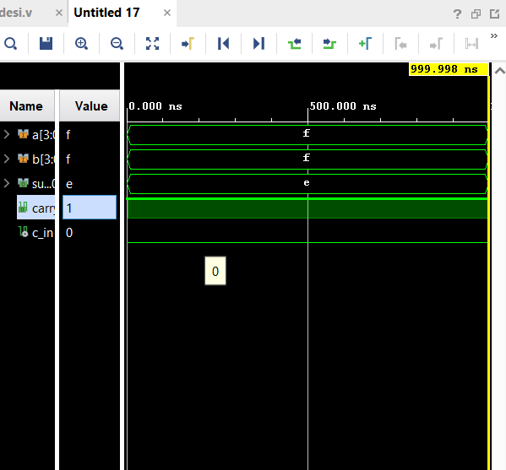

module desi(

input [3:0] a,b,

output [3:0] sum,

output carry

);

wire c_in=0;

assign a=15;

assign b=15;

assign {carry,sum}=a+b+c_in;

initial begin

$monitor(" a=%b b=%b %b %b ",$realtime,a,b,sum,carry);

end

endmodule

6. 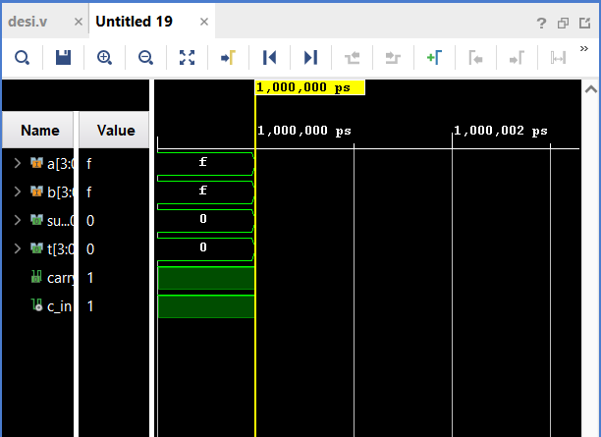

module desi(

input [3:0] a,b,

output [3:0] sum,t,

output carry

);

wire c_in=1;

assign a=15;

assign b=15;

assign t=b^{4{c_in}};

assign {carry,sum}=a+c_in+t;

initial begin

$monitor(" a=%b b=%b %b %b ",$realtime,a,b,sum,carry);

end

endmodule

7. 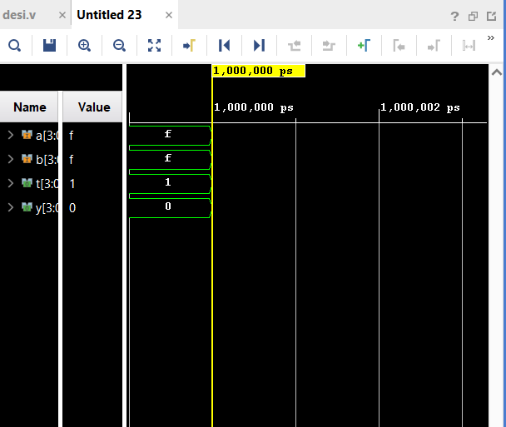

module desi(

input [3:0] a,b,

output [3:0] t,y

//output carry

);

// wire c_in=1;

assign a=15;

assign b=15;

assign t=a/b;

assign y=a%b;

initial begin

$monitor(" a=%b b=%b %b %b ",$realtime,a,b,t,y);

end

endmodule

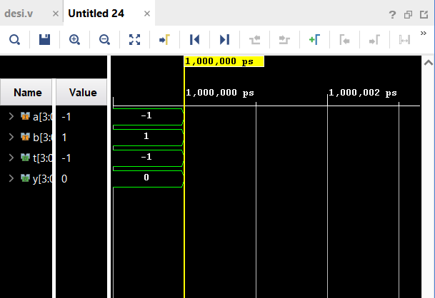

module desi(

input [3:0] a,b,

output [3:0] t,y

//output carry

);

// wire c_in=1;

assign a=15;

assign b=-15;

assign t=a/b;

assign y=a%b;

initial begin

$monitor(" a=%b b=%b %b %b ",$realtime,a,b,t,y);

end

endmodule

8. 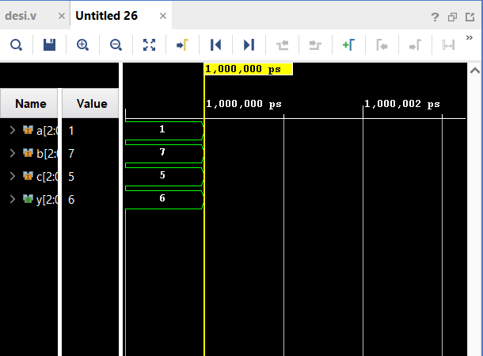

module desi(

input [2:0] a,b,c,

output [2:0] y

//output carry

);

assign y={a,b[0],c[1]};

assign a=1'b1;

assign b=3'b111;

assign c=3'b101;

initial begin

$monitor(" a=%b b=%b %b %b ",$realtime,a,b,c,y);

end

endmodule

9. 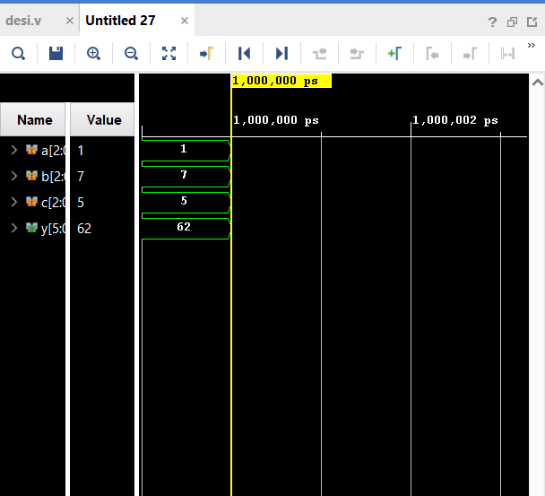

module desi(

input [2:0] a,b,c,

output [5:0] y

//output carry

);

assign y = {a, {4{b[0]}}, c[1]};

assign a=1'b1;

assign b=3'b111;

assign c=3'b101;

initial begin

$monitor(" a=%b b=%b %b %b ",$realtime,a,b,c,y);

end

endmodule

10. 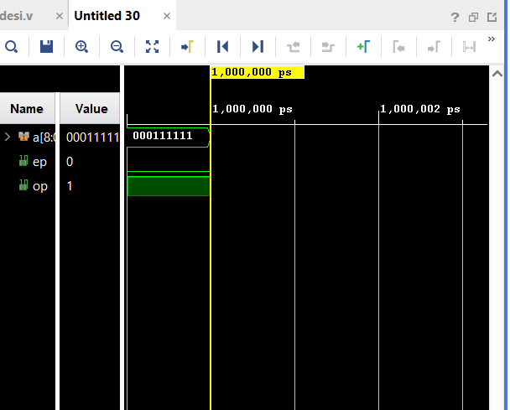

module desi(

input [8:0] a,

output ep,op

//output carry

);

assign ep =^a;

assign op=~ep;

assign a=9'b1000111111;

initial begin

$monitor(" a=%b b=%b %b %b ",$realtime,a,ep,op);

end

11. module desi(

input [8:0] a,

output ep,op

//output carry

);

assign ep =~(|a);

assign op=&a;

assign a=9'b1111111111;

initial begin

$monitor(" a=%b b=%b %b %b ",$realtime,a,ep,op);

end

endmodule

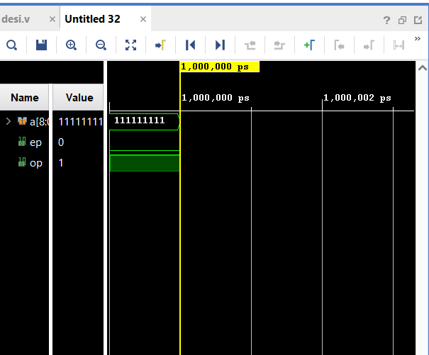

12. 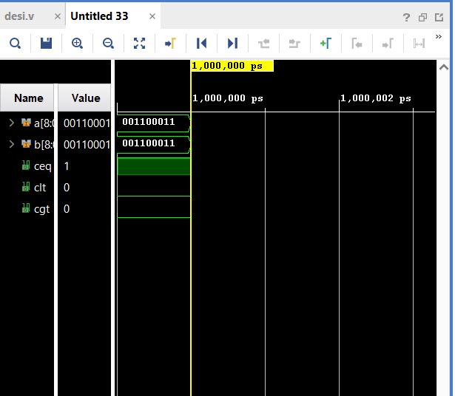

module desi(

input [8:0] a,b,

output ceq,clt,cgt

//output carry

);

assign ceq = a==b;

assign clt= a<b;

assign cgt=a>b;;

assign a=99;

assign b=99;

initial begin

$monitor(" a=%b b=%b %b %b %b ",$realtime,a,b,ceq,clt,cgt);

end

endmodule

14. 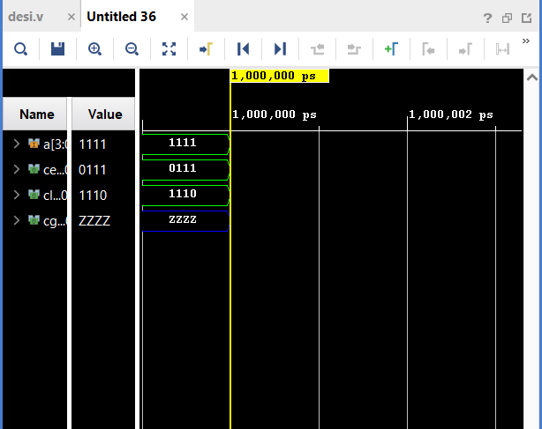

module desi(

input [3:0] a,

output [3:0] ceq,clt,cgt

//output carry

);

assign ceq = a>>1;

assign clt= a<<1;;

assign a=4'b1111;

// assign a=99;

//assign b=99;

initial begin

$monitor(" a=%b b=%b %b ",$realtime,a,ceq,clt);

end

endmodule

15. 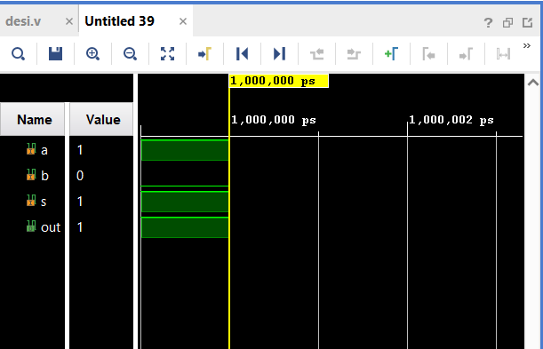

module mux4(

input a,b,

input s,

output out

//output carry

);

assign a=1;

assign b=0;

assign s=1;

assign out= s? a:b;

// assign a=99;

//assign b=99;

initial begin

$monitor(" a=%b b=%b %b %b ",$realtime,a,b,s,out);

end

endmodule

16. 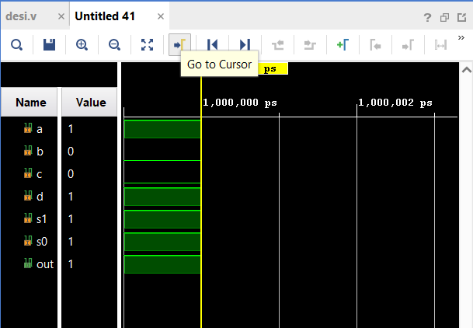

module mux4(

input a,b,c,d,

input s1,s0,

output out

//output carry

);

assign a=1;

assign b=0;

assign c=0;

assign d=1;

assign s1=1;

assign s0=1;

assign out= s1? (s0?a:b):(s0?c:d);

// assign a=99;

//assign b=99;

initial begin

$monitor(" a=%b b=%b %b %b %b %b %b ",$realtime,a,b,c,d,s1,s0,out);

end

endmodule

18. 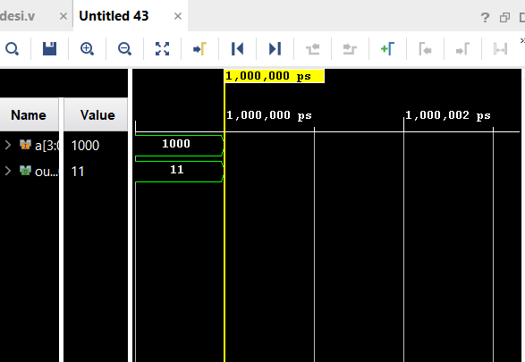

module mux4(

input[3:0] a,

output[1:0] out

//output carry

);

assign a=4'b1000;

assign out= (a==4'b1000)?2'b11:(a==4'b0100)?2'b10:(a==4'b0010)?2'b01:(a==4'b0001)?2'b00:(4'bzzzz);

// assign a=99;

//assign b=99;

initial begin

$monitor(" a=%b %b ",$realtime,a,out);

end

endmodule

19.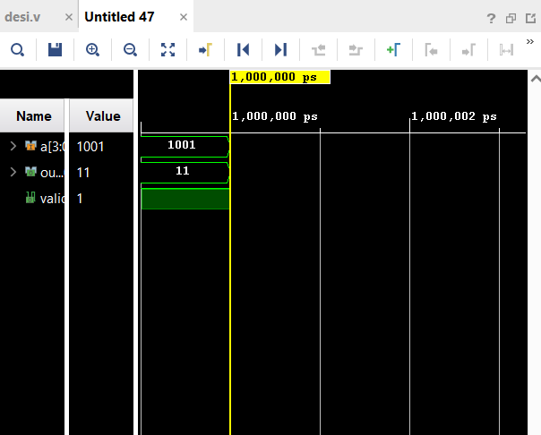

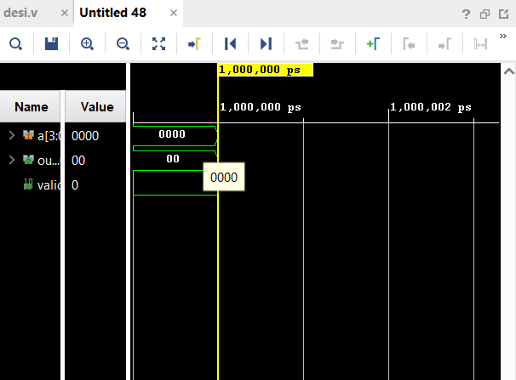

module mux4(

input[3:0] a,

output[1:0] out,

output valid

//output carry

);

assign a=4'b0000;

assign valid = a[3] | a[2] | a[1] | a[0];

//if (|a) begin

assign out = a[3] ? 2'b11 :a[2] ? 2'b10 :a[1] ? 2'b01 :a[0] ? 2'b00 : 2'b00; // De

//else begin

//assign out=4'bzzzz;

// assign a=99;

//assign b=99;

initial begin

$monitor(" a=%b %b %b ",$realtime,a,out,valid);

end

endmodule

17.

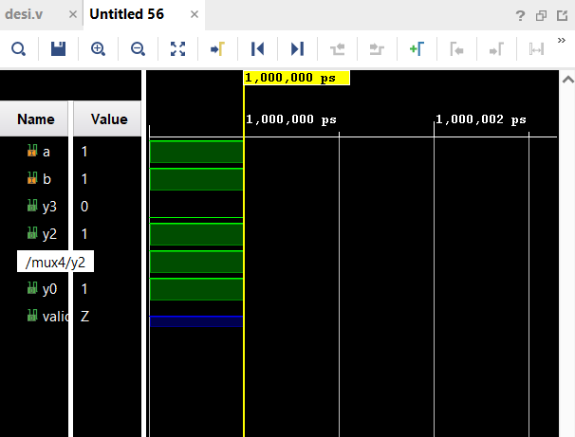

module mux4(

input a,b,

output y3,y2,y1,y0,

output valid

//output carry

);

assign y0=a|b;

assign y1=a|(~b);

assign y2=(~a)|b;

assign y3=(~a)|(~b);

assign a=1;

assign b=1;

//else begin

//assign out=4'bzzzz;

// assign a=99;

//assign b=99;

initial begin

$monitor(" a=%b %b %b %b %b ",$realtime,a,b,y3,y2,y1,y0);

end

endmodule

20. 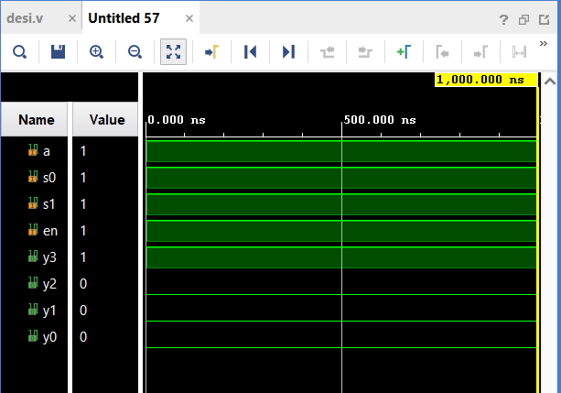

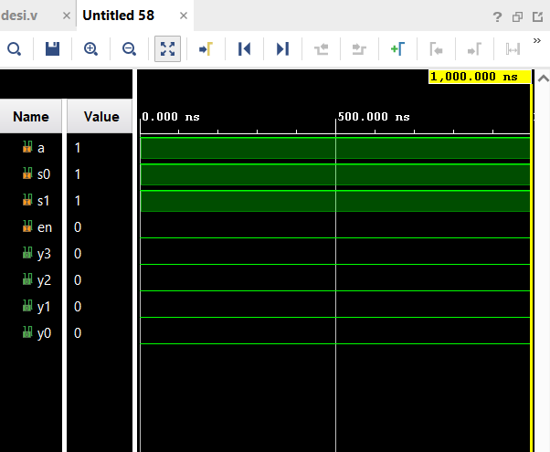

module mux4(

input a,s0,s1,en,

output y3,y2,y1,y0

//output carry

);

assign en=0;

assign a=1;

assign s0=1;

assign s1=1;

assign y0=en&~s0&~s1&a;

assign y1=en&s0&~s1&a;assign y2=en&~s0&s1&a;assign y3=en&s0&s1&a;

//else begin

//assign out=4'bzzzz;

// assign a=99;

//assign b=99;

initial begin

$monitor(" a=%b %b %b %b %b ",$realtime,a,y3,y2,y1,y0,s0,s1);

end

endmodule